- Photograph and Videos: Still Photograph
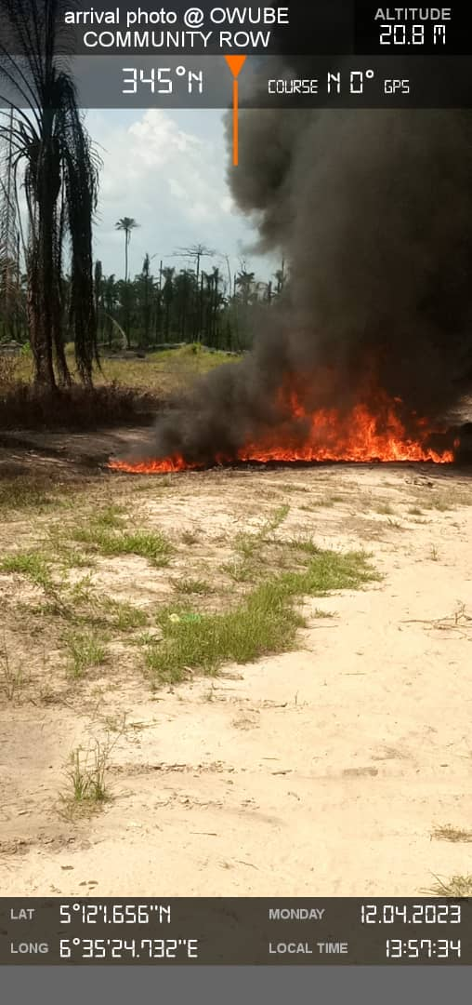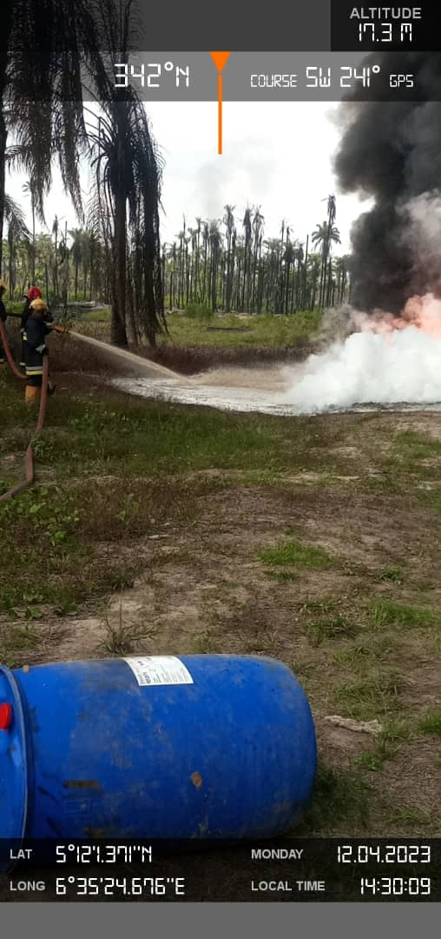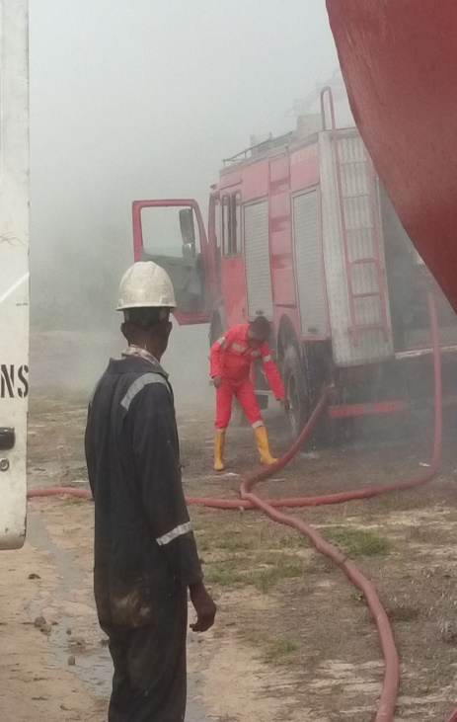
Figure 1: Fire incident at the Site Figure 2: Firefighting Figure 3: Fire Truck dispensing water
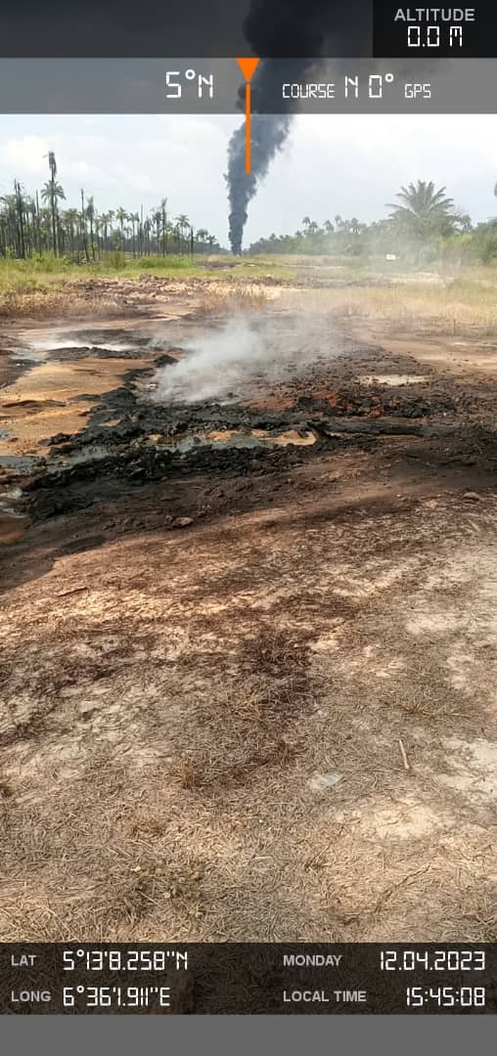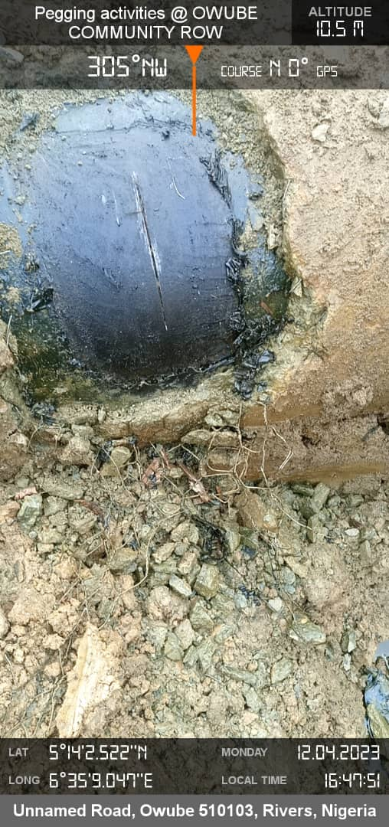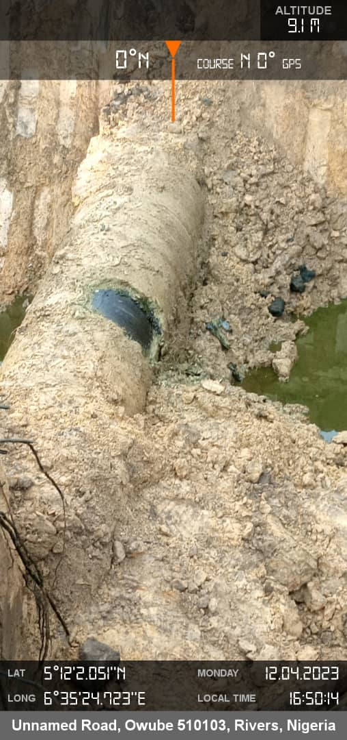
Fig.4: Burnt soil/vegetation (Impacted area) Fig.5: Spill point Fig.6: Oil found within the spill point

